**Appendix**

Contains links to [GitHub](https://github.com/kdahlquist/DahlquistLab) which contains files for raw data, PowerPoints containing the full set of figures, MATLAB code, and data analysis Excel files. Supplementary tables are also given under the sections.

[Online Notebook for Summer 2019 - Spring 2020](https://openwetware.org/mediawiki/index.php?title=Alice_Finton_Online_Lab_Notebook)

1. **STEM, k-means Clustering, and Gene Ontology**
   * **DNA Microarray Data Workbooks:**
     + *Found in*[*within-strain_ANOVA_results*](https://github.com/kdahlquist/DahlquistLab/tree/master/data/within-strain_ANOVA_results)
     + Contains the DNA microarray data for the wild-type and five transcription factor deletion strains used in the data analysis.
   * **STEM Profiles** (Figure 2)
     + *Found in*[*Data: STEM*](https://github.com/kdahlquist/DahlquistLab/tree/master/data/stem)
     + Contains PowerPoint of STEM profile analysis.
   * **ClueGO Gene Ontology Analysis** (Figure 3-5)
     + *Found in*[*STEM: downstream_analysis*](https://github.com/kdahlquist/DahlquistLab/tree/master/data/stem/downstream-analysis)
     + Contains PowerPoint file containing all ClueGO networks for the Gene Ontology analysis of the DNA microarray data.
   * ***k*-Means Clustering of the Microarray Data** (Figure 6)
     + *Found in* [*Microarray Data Clustering*](https://github.com/kdahlquist/DahlquistLab/tree/master/data/Spring2020/Microarray%20Data%20Clustering)
     + Contains Excel sheets containing clustered DNA microarray data
2. **Sensitivity of the Model to Network Structure and Strain Data**
   * **Systematic Deletion of Edges from the Db5 Network**
     + Model input and output found on GitHub in [MO.LK Edge Deletion Data](https://github.com/kdahlquist/DahlquistLab/tree/master/data/Spring2018/MO.LK%20Edge%20Deletion%20Data) (Figure 7)
     + PowerPoint of clustered heatmap (Figure 8)
   * **Gcr2 and Zap1 Node Deletion Model Runs**
     + *Found in* [*Gcr2 and Zap1 Node Deletion Model Runs*](https://github.com/kdahlquist/DahlquistLab/tree/master/data/Spring2020/Sensitivity%20of%20Model%20to%20Network%20Changes%20and%20Strain%20Data/Gcr2%20and%20Zap1%20Node%20Deletion%20Model%20Runs)
     + Excel sheet containing LSE:minLSE ratio analyses (Figure 10)
   * **Variable Inclusion of Strain Data:**
     + *Found in*[*Data: Summer 2019*](https://github.com/kdahlquist/DahlquistLab/tree/master/data/Summer2019)
     + Table of model runs
     + PowerPoint of all expression plots (Figure 16)
     + Excel sheets containing bar graphs for production rates and thresholds
     + Excel sheets containing compiled production rates, thresholds, and weights for all model runs.
     + Excel sheet containing LSE:minLSE ratio for the variable inclusion runs. (Figure 11)
     + PowerPoint of all Gene Regulatory Networks for the model runs (Figures 12-14)

|  |  |  |  |  |  |  |
| --- | --- | --- | --- | --- | --- | --- |
| **Table1**: Checks designate which data was included in the model run | | | | | | |
| Model Run | *Wild-Type* | *𝚫cin5* | *𝚫gln3* | *𝚫hap4* | *𝚫hmo1* | *𝚫zap1* |
| All-strain | ✔ | ✔ | ✔ | ✔ | ✔ | ✔ |
|  | ✔ | ✔ | ✔ | ✔ | ✔ |  |
|  | ✔ | ✔ | ✔ | ✔ |  | ✔ |
|  | ✔ | ✔ | ✔ |  | ✔ | ✔ |
|  | ✔ | ✔ |  | ✔ | ✔ | ✔ |
|  | ✔ |  | ✔ | ✔ | ✔ | ✔ |
|  | ✔ | ✔ | ✔ | ✔ |  |  |
|  | ✔ | ✔ | ✔ |  | ✔ |  |
|  | ✔ | ✔ | ✔ |  |  | ✔ |
|  | ✔ | ✔ |  | ✔ | ✔ |  |
|  | ✔ | ✔ |  | ✔ |  | ✔ |
|  | ✔ | ✔ |  |  | ✔ | ✔ |
|  | ✔ |  | ✔ | ✔ | ✔ |  |
|  | ✔ |  | ✔ |  | ✔ | ✔ |
|  | ✔ |  |  | ✔ | ✔ | ✔ |
|  | ✔ | ✔ | ✔ |  |  |  |
|  | ✔ | ✔ |  | ✔ |  |  |
|  | ✔ | ✔ |  |  | ✔ |  |
|  | ✔ | ✔ |  |  |  | ✔ |
|  | ✔ |  | ✔ | ✔ |  |  |
|  | ✔ |  | ✔ |  | ✔ |  |
|  | ✔ |  | ✔ |  |  | ✔ |
|  | ✔ |  |  | ✔ | ✔ |  |
|  | ✔ |  |  | ✔ |  | ✔ |
|  | ✔ |  |  |  | ✔ | ✔ |
|  | ✔ | ✔ |  |  |  |  |
|  | ✔ |  | ✔ |  |  |  |
|  | ✔ |  |  | ✔ |  |  |
|  | ✔ |  |  |  | ✔ |  |
|  | ✔ |  |  |  |  | ✔ |
|  | ✔ |  |  |  |  |  |

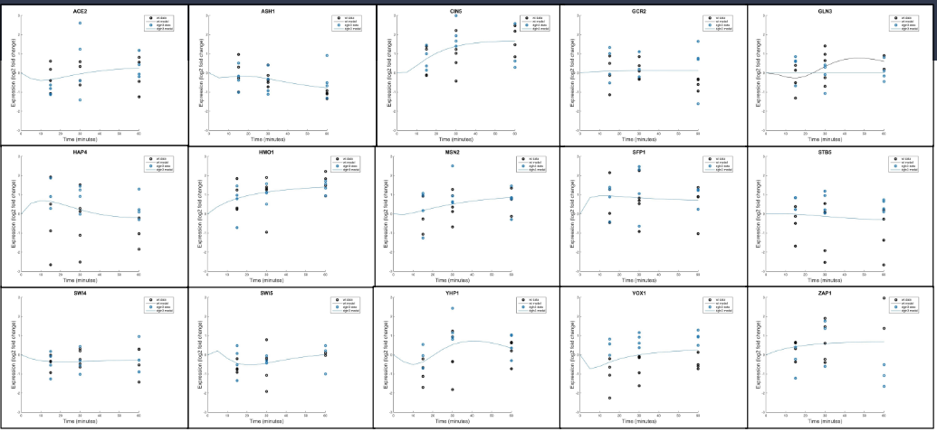

**Figure 1:** Expression plots for dGLN3.

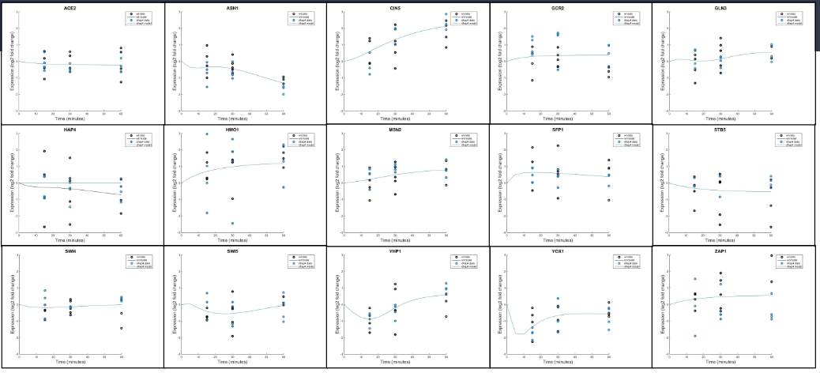

**Figure 2:** Expression plots for dHAP4

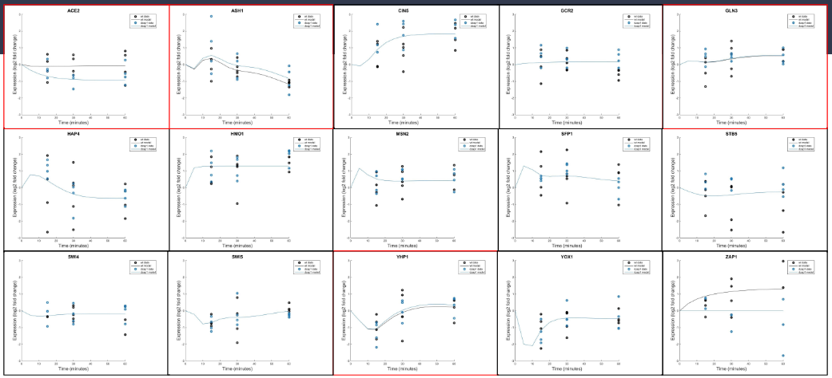

**Figure 3:** Expression plots for dZAP1.

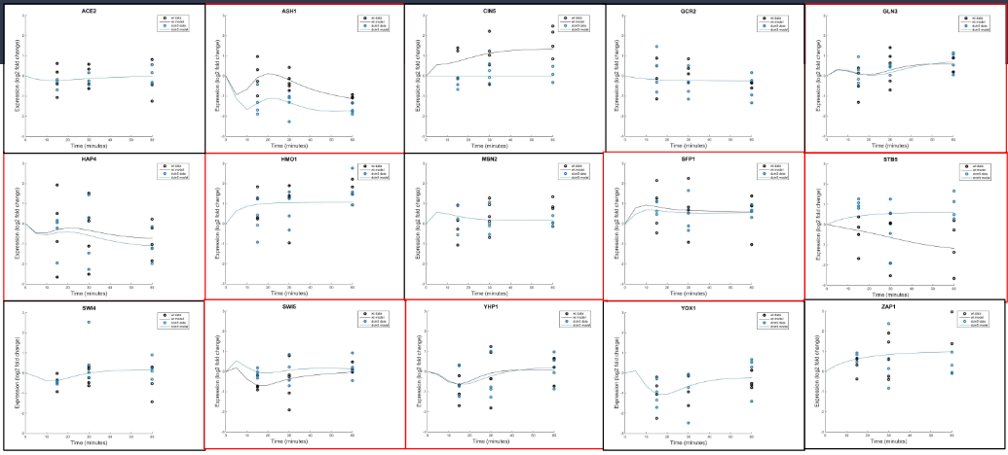

**Figure 4:** Expression plots for dCIN5.

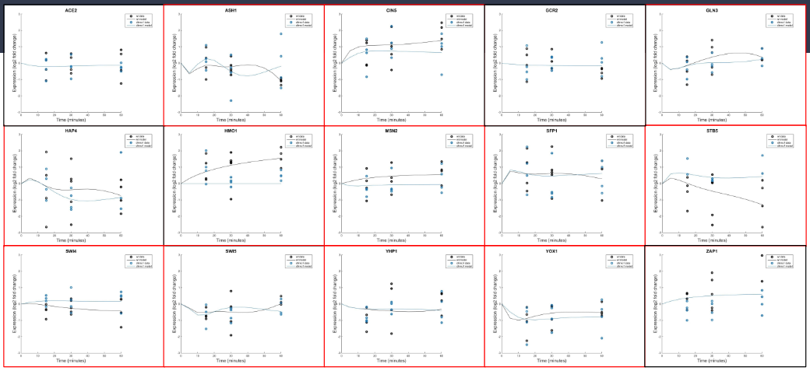

**Figure 5:** Expression plots for dHMO1.

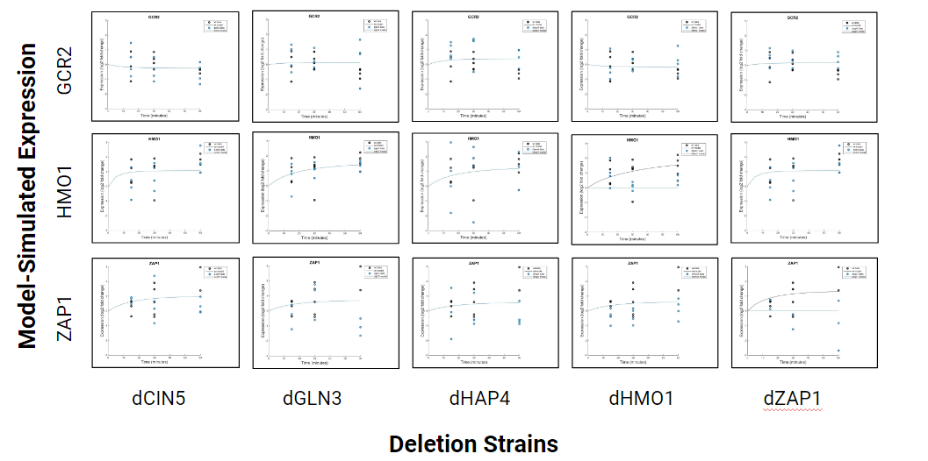

**Figure 6:**Model-simulated expression of GCR2, HMO1, and ZAP1 did not diverge from wild-type in model runs that included wt + one other strain

1. **Sensitivity Assessment of the Model to Changing Production Rates**
   * **Production Rate Comparison with Neymotin et al. (2014) Values**
     + *Found* [*in Production Rate Comparison with Neymotin et al. (2014)*](https://github.com/kdahlquist/DahlquistLab/tree/master/data/Spring2020/Sensitivity%20of%20Model%20to%20Production%20Rate%20Change/Production%20Rate%20Comparison%20with%20Neymotin%20Values)
     + Neymotin et al. (2014) supplementary table 5 modified to calculate production rates (Table 3)
     + PowerPoint containing Neymotin et al. (2014), initial guess, and model-estimated production rate comparison (Figure 17)
   * **Fix/Estimate Weights, Thresholds, and Production Rates Model runs:**
     + *Found in*[*Data: Fall 2019*](https://github.com/kdahlquist/DahlquistLab/tree/master/data/Fall2019)
     + Model input and output files (Table 7)
     + Excel sheets containing LSE:minLSE ratio analyses (Figure 18)
     + Excel sheets containing the compiled parameters
2. **Sensitivity Assessment of the Model to Manipulation of Optimization Parameters**
   * *Found in*[*Data: Fall 2019*](https://github.com/kdahlquist/DahlquistLab/tree/master/data/Fall2019)
   * **Manipulation of Optimization Parameters:**
     + Contains model input and output files (Table 5)
     + Compiled LSE:minLSE ratio and iteration count analyses (Figure 19)

|  |  |  |  |  |  |  |  |
| --- | --- | --- | --- | --- | --- | --- | --- |
| **Table 2:** Production rates for the standard, kk_Max 10, and TolX 1.00x10-07 are given along with the difference between the values, and the percent change (%). | | | | | | | |
|  | **Standard Model** | **kk_Max 10** | **TolX 1.00E-07** | **Standard - kk_Max 10** | **Percent Change (%)** | **Standard - TolX 1.00E-07** | **Percent Change (%)** |
| **ACE2** | 0.202 | 0.199 | 0.198 | 0.003 | 1.572 | 0.004 | 1.942 |
| **ASH1** | 1.677 | 1.670 | 1.668 | 0.007 | 0.410 | 0.009 | 0.521 |
| **CIN5** | 0.656 | 0.654 | 0.653 | 0.002 | 0.277 | 0.002 | 0.356 |
| **GCR2** | 0.232 | 0.232 | 0.232 | 0.000 | -0.001 | 0.000 | -0.001 |
| **GLN3** | 0.302 | 0.301 | 0.301 | 0.001 | 0.218 | 0.001 | 0.282 |
| **HAP4** | 1.302 | 1.295 | 1.293 | 0.007 | 0.545 | 0.009 | 0.686 |
| **HMO1** | 0.307 | 0.304 | 0.303 | 0.003 | 1.030 | 0.004 | 1.328 |
| **MSN2** | 2.557 | 2.551 | 2.549 | 0.006 | 0.232 | 0.008 | 0.298 |
| **SFP1** | 1.555 | 1.547 | 1.545 | 0.007 | 0.467 | 0.009 | 0.587 |
| **STB5** | 0.120 | 0.120 | 0.120 | 0.000 | 0.043 | 0.000 | 0.056 |
| **SWI4** | 0.316 | 0.312 | 0.311 | 0.004 | 1.138 | 0.005 | 1.477 |
| **SWI5** | 1.921 | 1.912 | 1.909 | 0.009 | 0.479 | 0.012 | 0.624 |
| **YHP1** | 0.208 | 0.207 | 0.207 | 0.001 | 0.561 | 0.001 | 0.714 |
| **YOX1** | 1.391 | 1.376 | 1.373 | 0.015 | 1.059 | 0.018 | 1.324 |
| **ZAP1** | 0.128 | 0.128 | 0.128 | 0.000 | 0.005 | 0.000 | 0.007 |

|  |  |  |  |  |  |  |  |
| --- | --- | --- | --- | --- | --- | --- | --- |
| **Table 3:** Threshold values for standard, kk_Max 10, and TolX 1.00x10-07 are given along with the difference between the values, and the percent change (%). | | | | | | | |
|  | **Standard Model** | **kk_Max 10** | **TolX 1.00E-07** | **Standard- kk_Max 10** | **Percent Change (%)** | **Standard -TolX 1.00E-07** | **Percent Change (%)** |
| **ACE2** | 0.899 | 0.876 | 0.871 | 0.022 | 2.498 | 0.028 | 3.094 |
| **ASH1** | 2.582 | 2.581 | 2.581 | 0.001 | 0.055 | 0.001 | 0.049 |
| **CIN5** | -0.478 | -0.484 | -0.486 | 0.006 | -1.315 | 0.008 | -1.678 |
| **GCR2** | 0.000 | 0.000 | 0.000 | 0.000 | - | 0.000 | - |
| **GLN3** | 0.694 | 0.693 | 0.693 | 0.001 | 0.149 | 0.001 | 0.188 |
| **HAP4** | 3.611 | 3.609 | 3.607 | 0.002 | 0.057 | 0.004 | 0.106 |
| **HMO1** | 1.646 | 1.637 | 1.635 | 0.009 | 0.541 | 0.011 | 0.698 |
| **MSN2** | -1.461 | -1.467 | -1.468 | 0.005 | -0.363 | 0.007 | -0.475 |
| **SFP1** | -0.294 | -0.303 | -0.305 | 0.009 | -3.024 | 0.011 | -3.800 |
| **STB5** | -1.596 | -1.598 | -1.599 | 0.002 | -0.141 | 0.003 | -0.181 |
| **SWI4** | -0.902 | -0.934 | -0.944 | 0.032 | -3.572 | 0.042 | -4.648 |
| **SWI5** | -1.784 | -1.790 | -1.791 | 0.006 | -0.308 | 0.007 | -0.385 |
| **YHP1** | -0.314 | -0.321 | -0.321 | 0.008 | -2.423 | 0.008 | -2.434 |
| **YOX1** | -0.448 | -0.451 | -0.450 | 0.003 | -0.681 | 0.003 | -0.599 |
| **ZAP1** | 0.000 | 0.000 | 0.000 | 0.000 | - | 0.000 | - |

|  |  |  |  |  |  |  |  |
| --- | --- | --- | --- | --- | --- | --- | --- |
| **Table 4:** Weight values for standard, kk_Max 10, and TolX 1.00x10-07 are given along with the difference between the values, and the percent change (%). | | | | | | | |
| **Edge** | **Standard Model** | **kk_Max 10** | **TolX 1.00E-07** | **Standard-kk_Max 10** | **Percent Change (%)** | **Standard-TolX 1.00E-07** | **Percent Change (%)** |
| **ACE2-->ASH1** | -1.167 | -1.169 | -1.169 | 0.001 | -0.116 | 0.002 | -0.144 |
| **ASH1-->YHP1** | -1.573 | -1.580 | -1.581 | 0.006 | -0.402 | 0.008 | -0.515 |
| **CIN5-->HAP4** | 0.280 | 0.280 | 0.281 | -0.001 | -0.248 | -0.001 | -0.313 |
| **CIN5-->SFP1** | -0.074 | -0.074 | -0.074 | 0.000 | -0.182 | 0.000 | -0.229 |
| **CIN5-->STB5** | -0.443 | -0.443 | -0.443 | 0.000 | -0.092 | 0.001 | -0.118 |
| **CIN5-->YHP1** | 0.284 | 0.286 | 0.286 | -0.002 | -0.535 | -0.002 | -0.685 |
| **GCR2-->MSN2** | -3.388 | -3.390 | -3.391 | 0.002 | -0.070 | 0.003 | -0.094 |
| **HMO1->CIN5** | 0.826 | 0.828 | 0.828 | -0.002 | -0.200 | -0.002 | -0.257 |
| **HMO1-->HAP4** | -0.737 | -0.737 | -0.738 | 0.000 | -0.044 | 0.000 | -0.054 |
| **HMO1-->HMO1** | 0.670 | 0.675 | 0.676 | -0.005 | -0.714 | -0.006 | -0.925 |
| **HMO1-->MSN2** | 0.221 | 0.221 | 0.221 | 0.000 | -0.025 | 0.000 | -0.034 |
| **HMO1-->YOX1** | 0.556 | 0.557 | 0.558 | -0.001 | -0.180 | -0.001 | -0.224 |
| **MSN2-->ASH1** | -2.444 | -2.444 | -2.444 | 0.000 | 0.000 | 0.000 | 0.006 |
| **MSN2->CIN5** | -1.485 | -1.488 | -1.489 | 0.003 | -0.178 | 0.003 | -0.225 |
| **MSN2-->HAP4** | 2.987 | 2.988 | 2.988 | -0.001 | -0.025 | -0.001 | -0.021 |
| **MSN2-->SFP1** | -0.124 | -0.124 | -0.124 | 0.000 | -0.200 | 0.000 | -0.242 |
| **MSN2-->SWI4** | -0.866 | -0.875 | -0.878 | 0.009 | -1.012 | 0.011 | -1.314 |
| **MSN2-->YHP1** | 0.089 | 0.091 | 0.092 | -0.003 | -2.936 | -0.004 | -4.373 |
| **MSN2-->YOX1** | -1.983 | -1.983 | -1.982 | 0.000 | 0.022 | -0.001 | 0.046 |
| **SFP1-->SWI5** | -2.850 | -2.850 | -2.850 | 0.000 | -0.011 | 0.000 | -0.007 |
| **STB5-->HAP4** | 0.774 | 0.779 | 0.781 | -0.005 | -0.660 | -0.006 | -0.830 |
| **STB5-->SFP1** | -0.549 | -0.550 | -0.550 | 0.001 | -0.188 | 0.001 | -0.237 |
| **SWI4-->HAP4** | -2.953 | -2.957 | -2.958 | 0.004 | -0.127 | 0.005 | -0.186 |
| **SWI4-->YHP1** | -0.023 | -0.021 | -0.019 | -0.002 | 7.223 | -0.003 | 15.178 |
| **SWI4-->YOX1** | -0.260 | -0.252 | -0.249 | -0.008 | 3.073 | -0.011 | 4.114 |
| **SWI5-->ASH1** | 5.212 | 5.218 | 5.219 | -0.005 | -0.099 | -0.007 | -0.134 |
| **YHP1--GLN3** | 1.518 | 1.524 | 1.526 | -0.006 | -0.422 | -0.008 | -0.549 |
| **ZAP1-->ACE2** | 0.772 | 0.780 | 0.782 | -0.008 | -1.052 | -0.010 | -1.309 |

1. **Revisiting the Dahlquist et al. (2015) GRN model**
   * *Found on GitHub in*[*Data: Fall 2019*](https://github.com/kdahlquist/DahlquistLab/tree/master/data/Fall2019)
   * **Schade Network Model Runs**
     + PowerPoint containing Schade model run gene regulatory networks. (Figure 20)